Main Activity.java

Alaram system is a broadcast system,so need to create a reciver class

Imports:   
import android.view.View;  
import android.app.AlarmManager;  
import android.app.PendingIntent;  
import android.widget.TimePicker;  
import android.app.TimePickerDialog;  
import java.util.Calendar;  
import android.content.Intent;  
import android.content.Context;  
import android.widget.Toast;

Broad cast reciver :

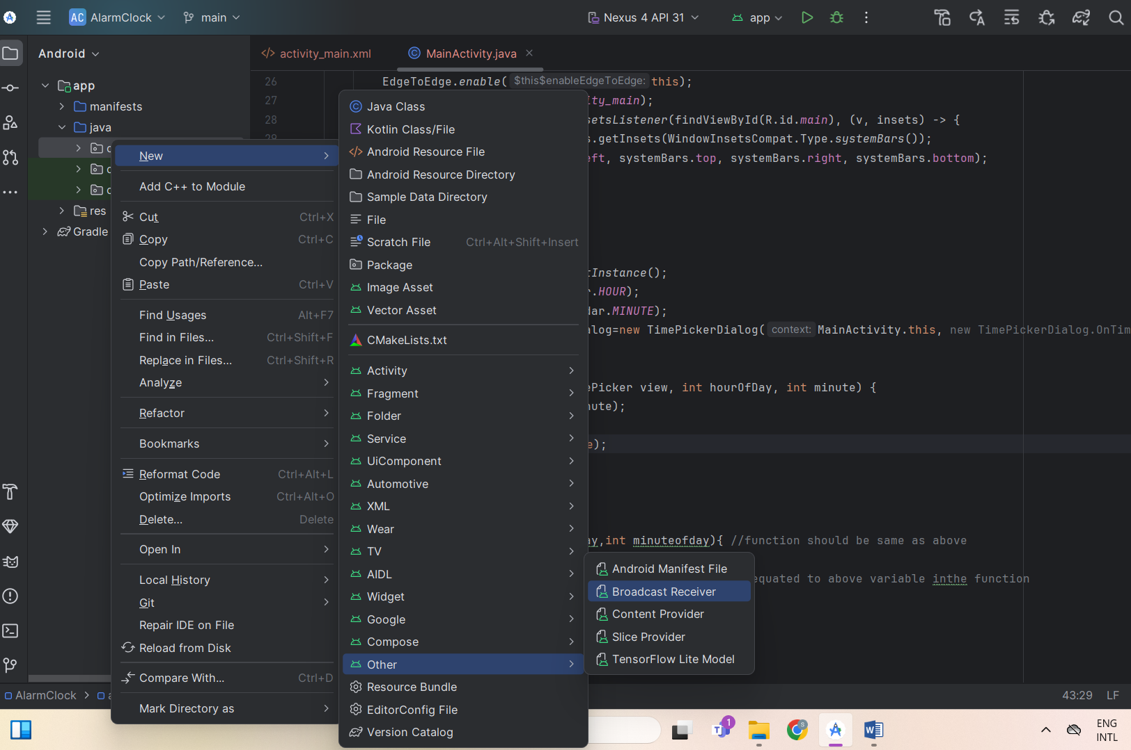

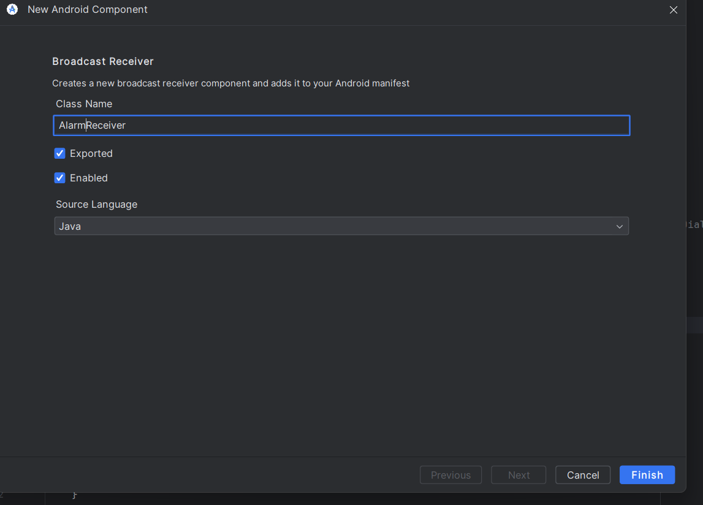

Manfiest:

</activity>  
</application>  
<uses-permission android:name="android.permission.WAKE_LOCK"/>